FIT5120 Industry Experience Studio Project

Data Governance and Management

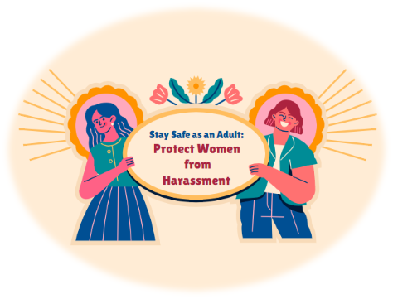

**TA25 GOT-G:**

Yang Ge

Wenjun Ma

Regina Valentina

Xinyu Wang

Yining Zhou

Table of Contents

**Introduction** **3**

**Data Sources (Open Datasets) Details** **3**

Dataset Details 3

Data Gathering 5

Crime records in Victoria 5

Suburb/ Locality Boundaries in Victoria 5

Australian Postcode 6

Feature Lighting 6

**Dataset Usage** **8**

Epic 2: Dangerous Area 8

Epic 7: Victoria Crime Records Visualisation 8

**Data wrangling and cleaning** **8**

Crime records dataset 8

Digital suburb boundaries 10

Australian Postcode Dataset 10

**Database Details Dataset Storage** **15**

**Data Security** **16**

**User Privacy** **16**

**Data Reflection** **16**

Iteration 1 16

Iteration 2 17

# **Introduction**

This document comprises the information, usage, and all the details of the data sources that are used by the GOT-G team to develop the GirlSafe application and website. The process of how the data being updated or transposed into the application, including the analysis or modelling is also described here.

# **Data Sources (Open Datasets) Details**

## Dataset Details

Here are the detailed information of the data sources used by the GOT-G team:

| **Names** | **Physical access** | **Frequency of source updates** | **Frequency of iteration system updates** | **Granularity** | **Copyright/licensing details** |
| --- | --- | --- | --- | --- | --- |
| Crime records in Victoria (area)  Link: <https://www.crimestatistics.vic.gov.au/crime-statistics/latest-victorian-crime-data/download-data> | CSV downloaded | Quarterly ( every 4 months) | 2 month after source updates | Number of crime records recorded in each suburb in Victoria | <https://creativecommons.org/licenses/by/4.0/>  When reporting this data you must attribute the Crime Statistics Agency (or CSA) as the source. |
| Suburb/ Locality Boundaries in Victoria  Link:  <https://data.gov.au/data/dataset/vic-suburb-locality-boundaries-geoscape-administrative-boundaries/resource/02dd5644-7542-4e95-ab71-1707010b99a6> | Shapefile downloaded | Quarterly | 2 month after source updates | Digital boundaries (spatial data) of the suburbs in Victoria | <https://creativecommons.org/licenses/by/4.0/>  Attribution for Licensed Material:  Administrative Boundaries © Geoscape Australia licensed by the Commonwealth of Australia under Creative Commons Attribution 4.0 International licence (CC BY 4.0). |
| Australian Postcode  Link:  <https://github.com/Elkfox/Australian-Postcode-Data/blob/master/au_postcodes.csv> | CSV downloaded | Last updated on December 23, 2016 | - | Postcode, latitude, and longitude of each suburb in Australia | [https://creativecommons.org/licenses/by/3.0/](https://creativecommons.org/licenses/by/4.0/)  The original source for this material is found at <https://github.com/Elkfox/Australian-Postcode-Data/blob/master/au_postcodes.csv> The dataset has been reformatted to fit the general purpose of the application |
| Crime records in Victoria (Victim report)  Link: <https://www.crimestatistics.vic.gov.au/crime-statistics/latest-victorian-crime-data/download-data> | CSV downloaded | Quarterly ( every 4 months) | 2 month after source updates | Number of crime records recorded in each Local Government Area in Victoria with the Victim detail (age range and gender) | <https://creativecommons.org/licenses/by/4.0/>  When reporting this data you must attribute the Crime Statistics Agency (or CSA) as the source. |
| Feature Lighting  Link:  <https://data.melbourne.vic.gov.au/City-Council/Feature-Lighting-including-light-type-wattage-and-/4j42-79hg/data> | CSV downloaded | Weekly (last updated October 2, 2021) | - | Location, lighting type and wattage of feature lighting across the City of Melbourne. | Data will be made available under flexible and open licenses, allowing for reuse by the public.  <https://creativecommons.org/licenses/by/4.0/> |

Other open datasets that can be explored (Backup):

<https://www.abs.gov.au/articles/sexual-violence-victimisation#key-statistics>

<https://www.abs.gov.au/statistics/people/crime-and-justice/personal-safety-australia/2016#data-download>

<https://www.aihw.gov.au/reports/domestic-violence/sexual-assault-in-australia/data>

<https://www.abs.gov.au/statistics/people/crime-and-justice/recorded-crime-victims/latest-release#data-download>

## Data Gathering

In this section we provide the step-by-step of how to collect the dataset from the link described in the previous section.

### Crime records in Victoria

* Go to the given website link

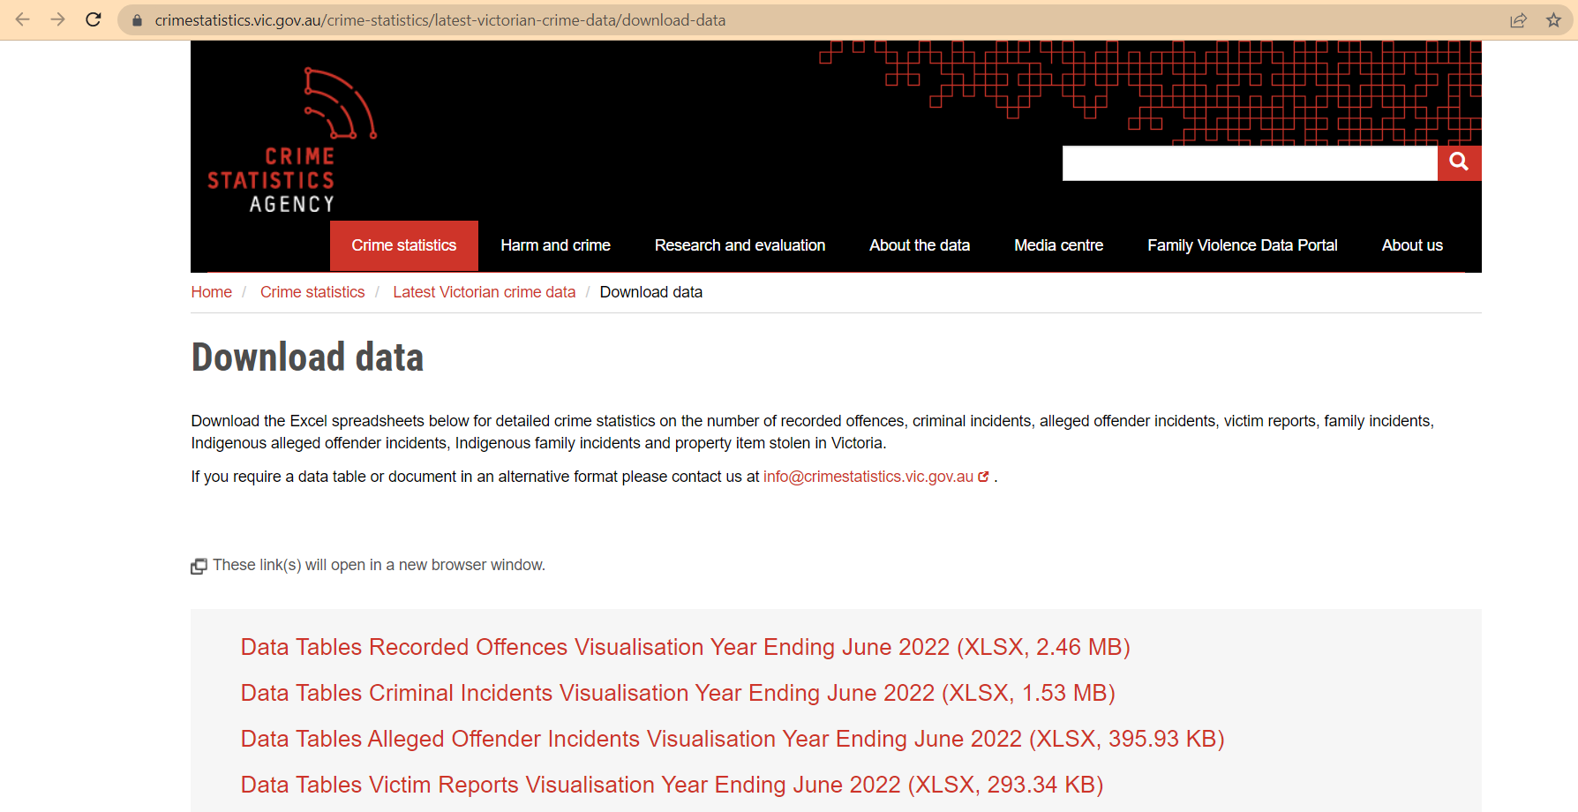

* Scroll down and find the “Data_Tables_LGA_Criminal_Incidents_Year_Ending_March_2022.xlsx”

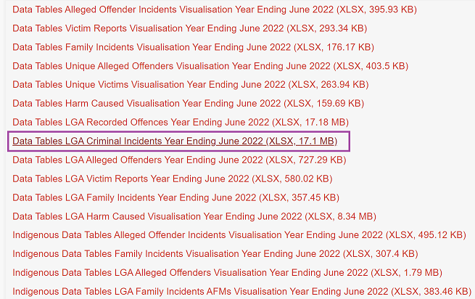

* Click on the text to automatically download the dataset

### Suburb/ Locality Boundaries in Victoria

* Go to the website link as described previously.

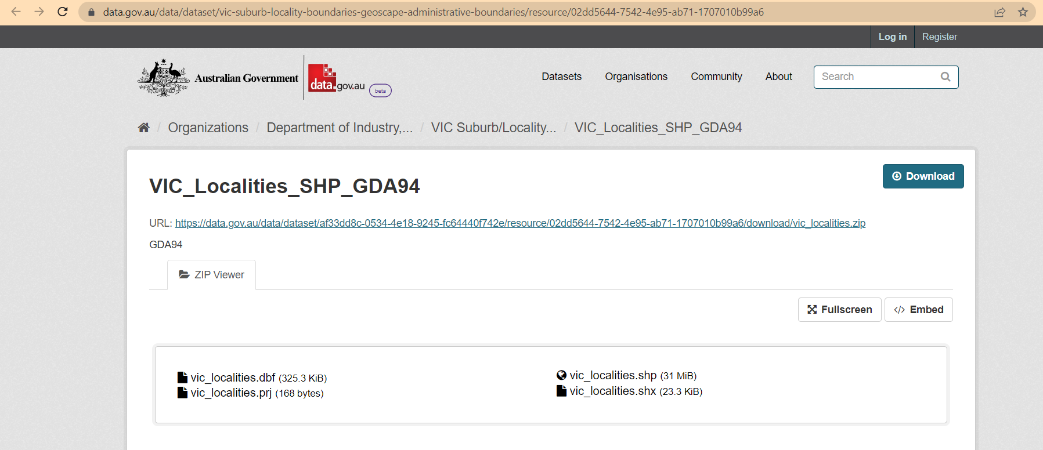

* Click either the “download” button or the given URL to download the dataset.

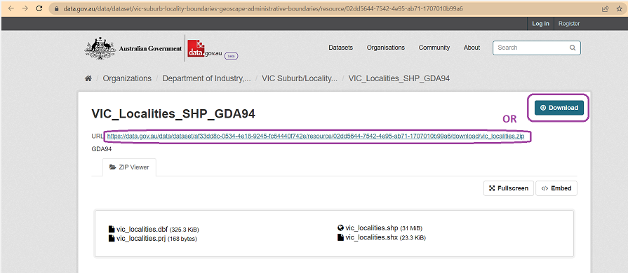

* The dataset will be automatically downloaded in a `zip` file format.

### Australian Postcode

* Go to the described website link.

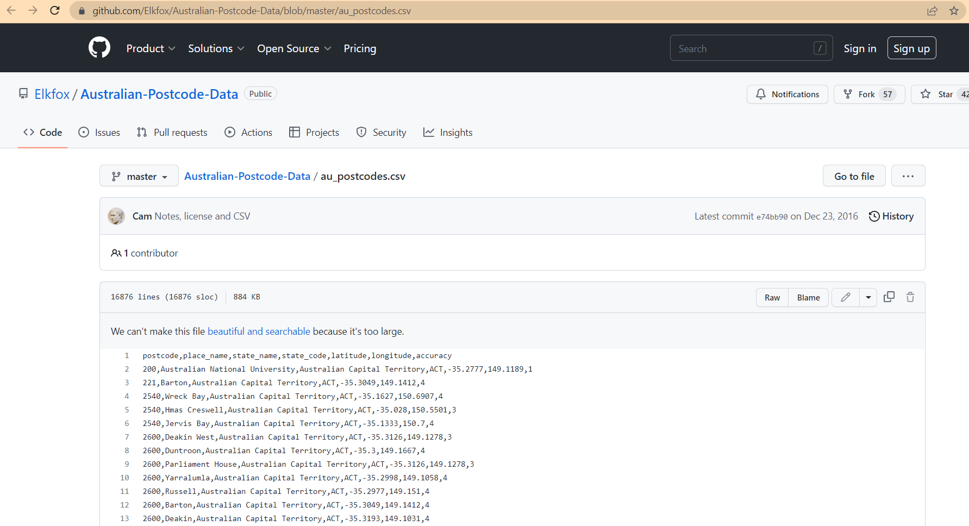

### Feature Lighting

* Go to the website link as described.

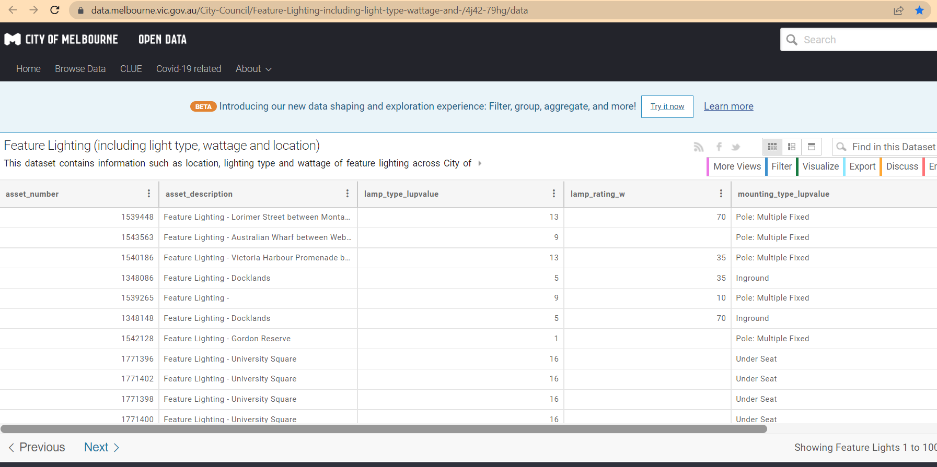

* Click on the “export” button.

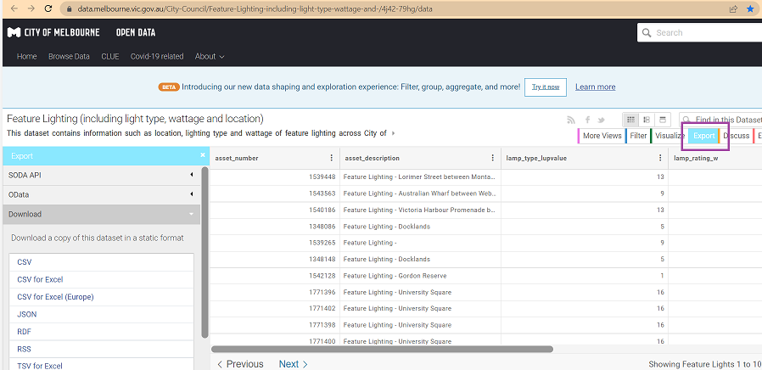

* Save the dataset in the desired file format (in this project, we use the CSV format).

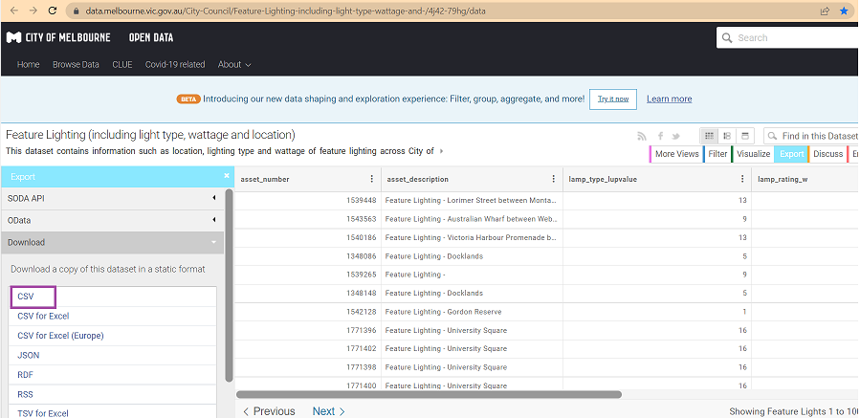

* The dataset will automatically downloaded into the local computer

# Dataset Usage

## Epic 2: Dangerous Area

We use the criminal records from the CSA (Crime Statistics Agency) to show the crime rate that can be used to indicate how safe the suburb is. The records are then visualised in a map so that the user can easily get an insight into the information. The suburb name and the postcode are used to connect the two datasets and can be used as the value for the user to filter the dataset based on their desire.

## Epic 7: Victoria Crime Records Visualisation

As we get the dataset of the crime records that happen in Victoria, we utilise the dataset to gain a piece of information that can help the user to be more aware. Here, we tried to provide the summary of the dataset and get the essential points for the user such as the crime rate that happens in Victoria, the type of crime that exists in Victoria, and the number of street harassment that are recorded in each suburb in Victoria.

# Data wrangling and cleaning

Pre-processing steps are performed with Python to clean the datasets:

## Crime records dataset

* The dataset is downloaded from the CSA site.
* Check on duplicates or missing data in the dataset to make sure the dataset is clean and reliable.

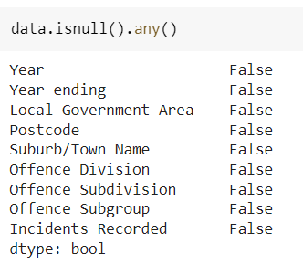

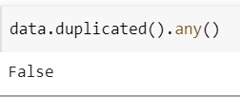

* Get the Offence Division of each crime records

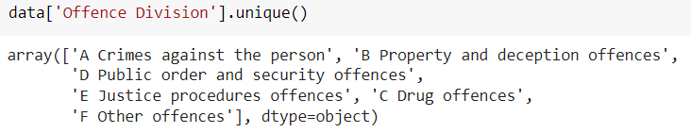

* Remove the Heading title of the Offence division

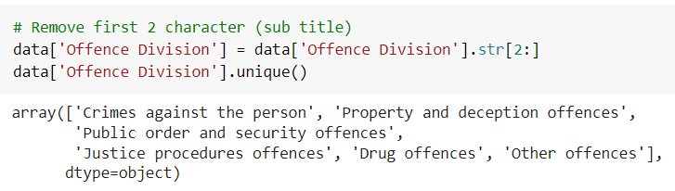

* Filter the dataset, only use the criminal records of the "Crimes against the person".

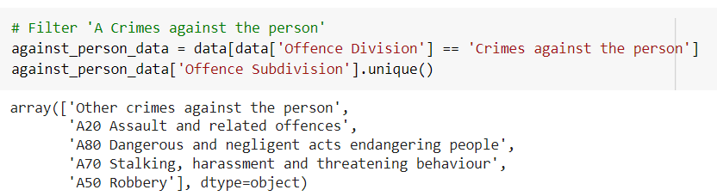

* Remove the Heading title of the Offence subdivision, but exclude the crime type 'Other crimes against the person'

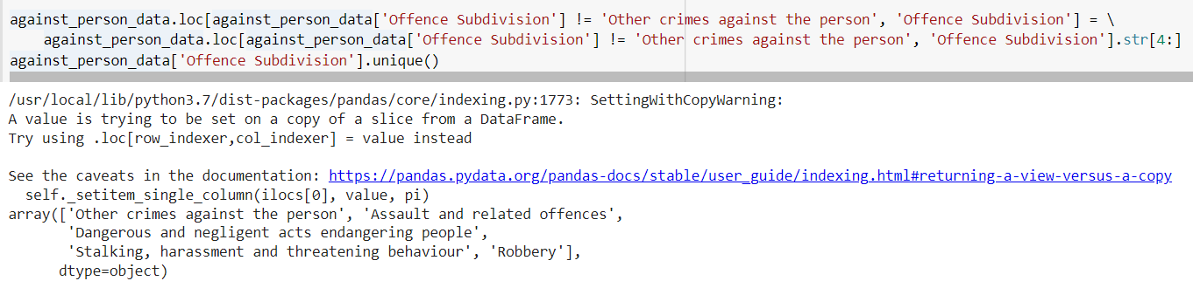

* Adjust (remove the sub-title) the 'Offence Subdivision'
* Remove unnecessary columns



* Export clean dataset to CSV format file.



## Digital suburb boundaries

* The shapefile dataset is downloaded from the source link.
* Read the shapefile dataset in the zip file format.

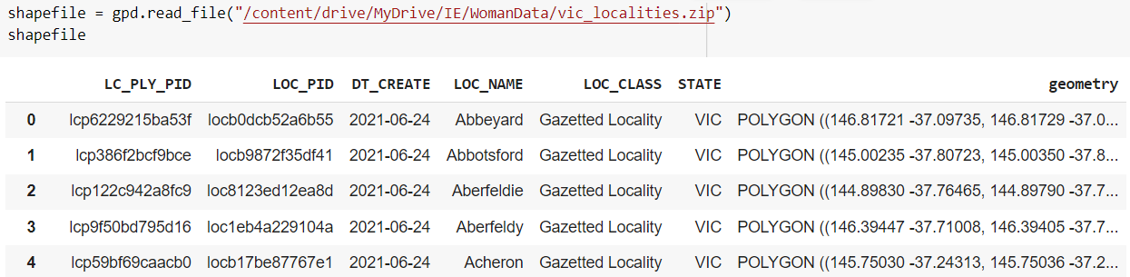

* Check on duplicates or missing data in the dataset to make sure the dataset is clean and reliable.

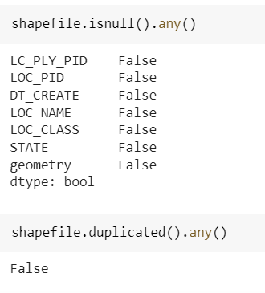

* Remove unnecessary columns

.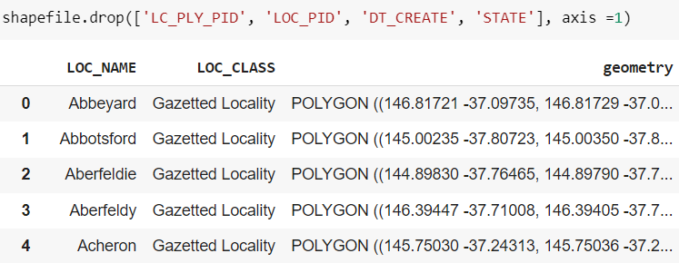

* Export the dataset



## Australian Postcode Dataset

* The dataset is downloaded from the source link.
* Check on duplicates or missing data in the dataset to make sure the dataset is clean and reliable.

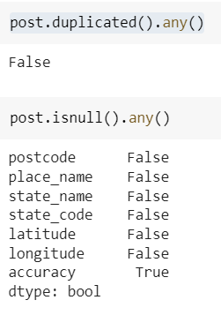

* Filter the dataset for Victoria areas only.

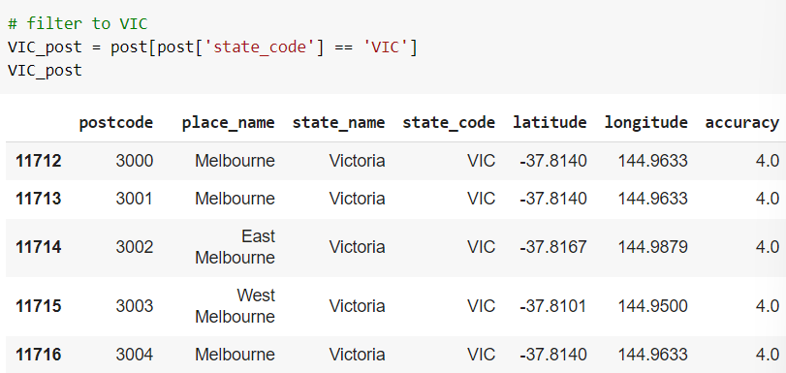

* Remove unneeded columns, including accuracy which contain a lot of missing values.



* Export clean dataset to CSV format file.



Further Data processing

* Join the postcode and suburb boundaries dataset.

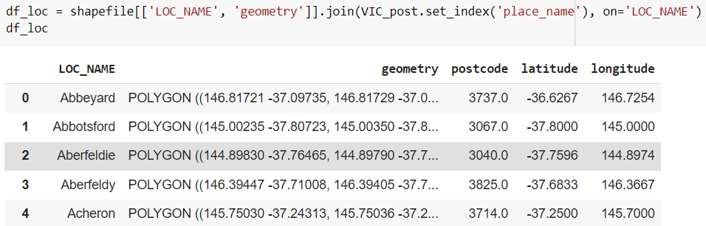

* Check for the area with missing values.

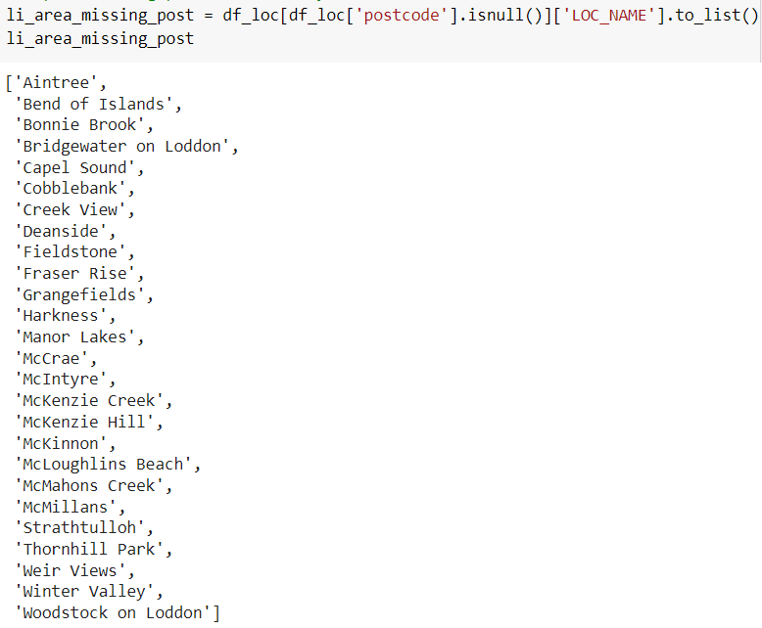

* Impute missing values.

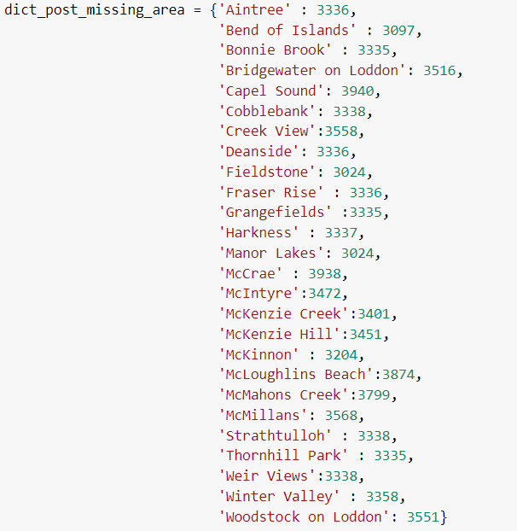

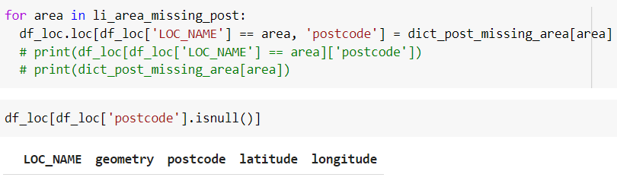

* Impute missing latitude and longitude with the centroid of the area.

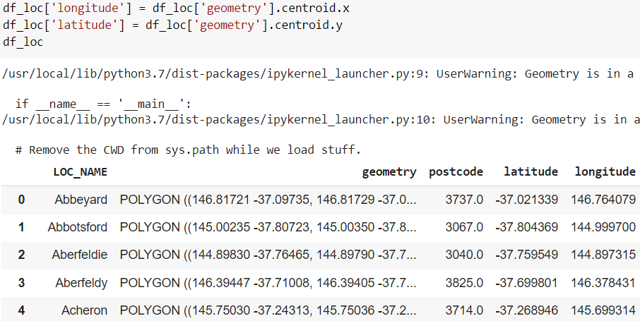

* Add id column for the suburb dataset

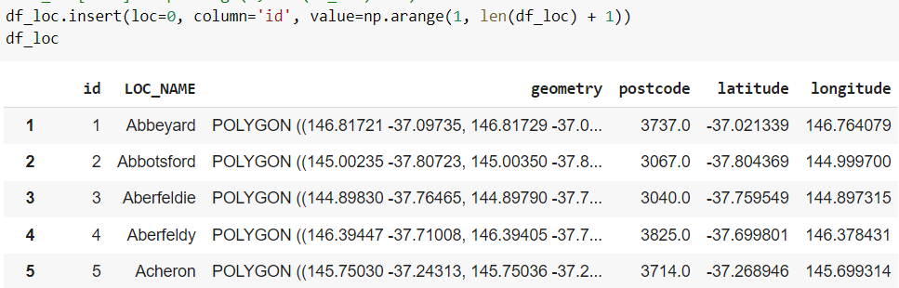

* Generate the location_id based on the suburb name and postcode key as reference to the location id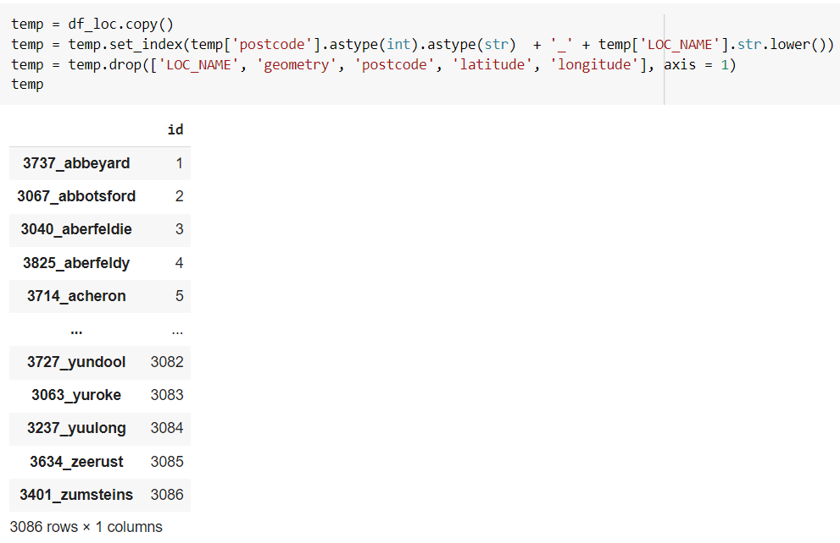
* Generate the tables (location and crime) with the location id as the relation between the two tables..

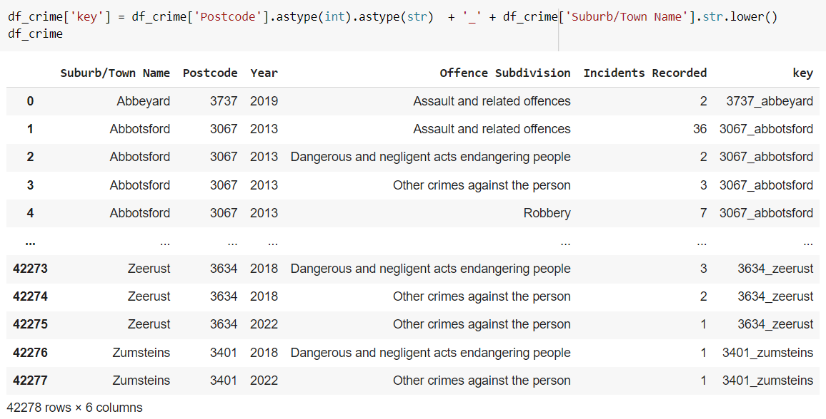

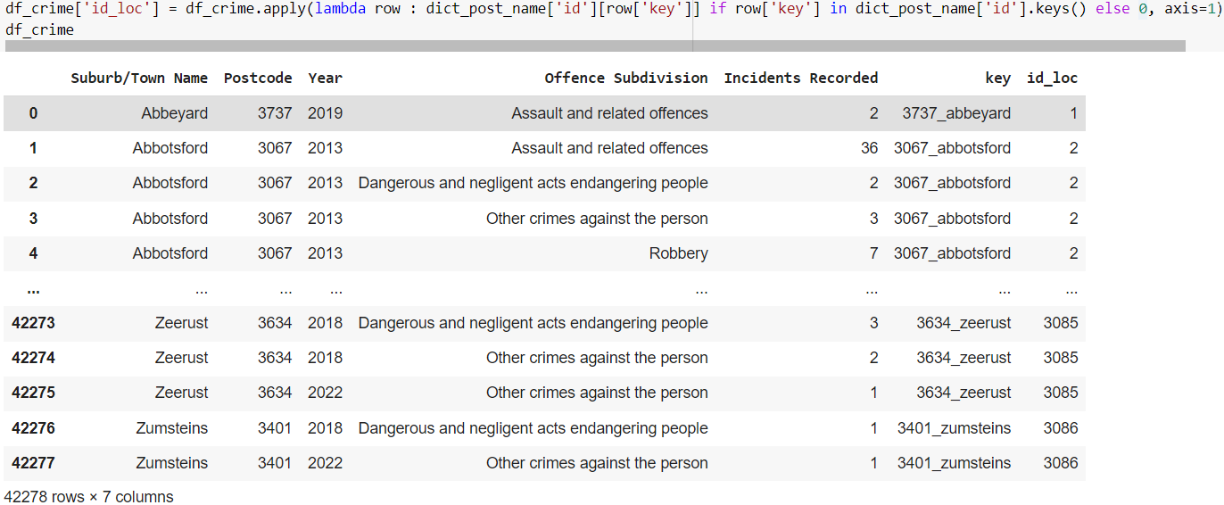

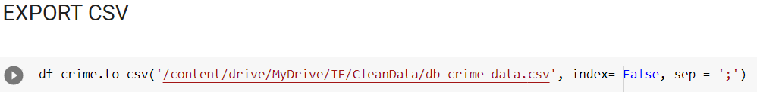

* Import the data into the database
* Perform data exploration and provide the result on the website for user insight.

# Database Details Dataset Storage

The modified crime dataset is stored in the database (local) while the map dataset is stored in the drive with CSV file format (called using a link) since the size is too big and takes too much memory for the application.

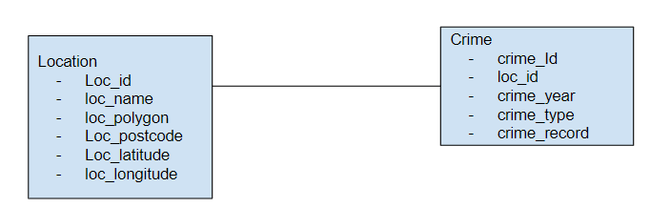

Figure 1: ER diagram plan for iteration 1

Link to sql script: <https://drive.google.com/drive/folders/1pCIvtYZ6yg5oSaquO2R-Usu0PCKbpxah>

# Data Security

This work is licensed under the [Creative Commons Attribution 4.0 International License](https://creativecommons.org/licenses/by/4.0/). You may share and redistribute the material in any medium or format. When using the material you must attribute the GOT-G as the source.

# User Privacy

This application may collect the information from the user such as the location, phone number of the closest person (emergency contact) to be utilised in the application features. The data is confidential and will not be shared with other users or other parties without the permission from the user. There will be a message prompted to let the user know that the application needs their permission to collect their personal information.

# Data Reflection

## Iteration 1

* + 1. Insight, hindsight, foresight

The seventh Epic, which is the "Victoria Crime Records Visualisation" is achieved using the criminal records dataset. Using the dataset, we provide the user a simple data visualisation to show the crime trend that happened in Victoria for the past 10 years. As we look back on what we did for the first iteration, the way we presented the data to the user is not friendly and engaging. As we only provide the dataset in the form of a barchart, line chart, and a simple table, the user might not be able to obtain the information we want to deliver from the data.

Therefore, this kind of decision is one of the common mistakes that happen when we perform a data visualisation, where we only focus on visualising the data and neglect the user’s point of view. Whereas the user’s perspective is supposed to be the most important thing that we consider in the first stage of the data visualisation.

Thus in the future iteration, we need to adjust and fix this issue by taking the user’s point of view as one of the consideration factors to visualise the data. Secondly, we can also deliver the important pieces of information as a story along with infographic images to obtain the user’s attention and make the information easier to understand. Therefore, the data can be fully utilised to provide a piece of reliable information and understanding to raise the user awareness about the topic we have.

## Iteration 2

The second Epic, which is the "Dangerous Area" can be fulfilled with the criminal records dataset, digital boundaries shapefile, and the postcode dataset. Using these datasets and the data visualisation, we can accomplish one of the goals which is to provide some insight to the user about the safe and unsafe areas in Victoria so they can raise their awareness.

After the implementation of the dataset to develop the features, there is an ambiguity within the limits to determine the safe and unsafe areas. There are some areas with no criminal records (either missing data or no criminal action reported) which need further exploration and checking. The population of each suburb can also be one of the factors for the high records of criminal records that happen. Thus, we need to take this into consideration to provide a piece of reliable information for the user.

Collecting the open dataset of the population in each suburb and providing the crime rate based on the population might be more reliable rather than the number of criminal records that happen in each suburb. We can use the population to provide the probability of a crime that might happen in a particular area for the user to take a concern to.